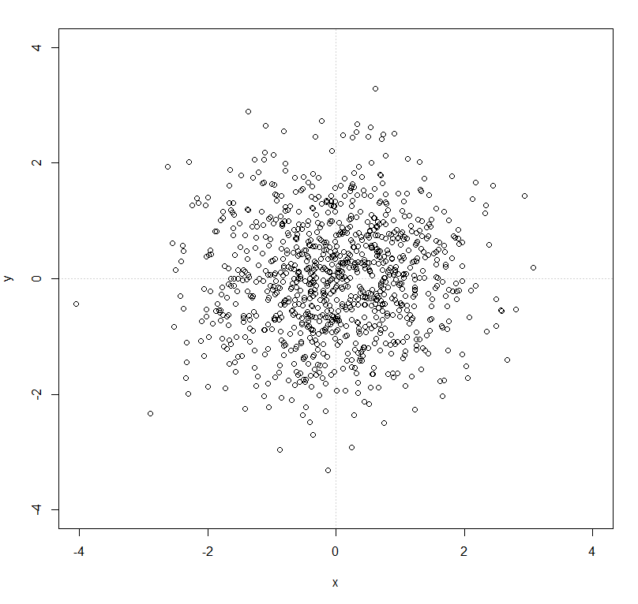

Odometry motion model, initial pose (0,0), control (0,0,0), position noise sampled from N(0,1)

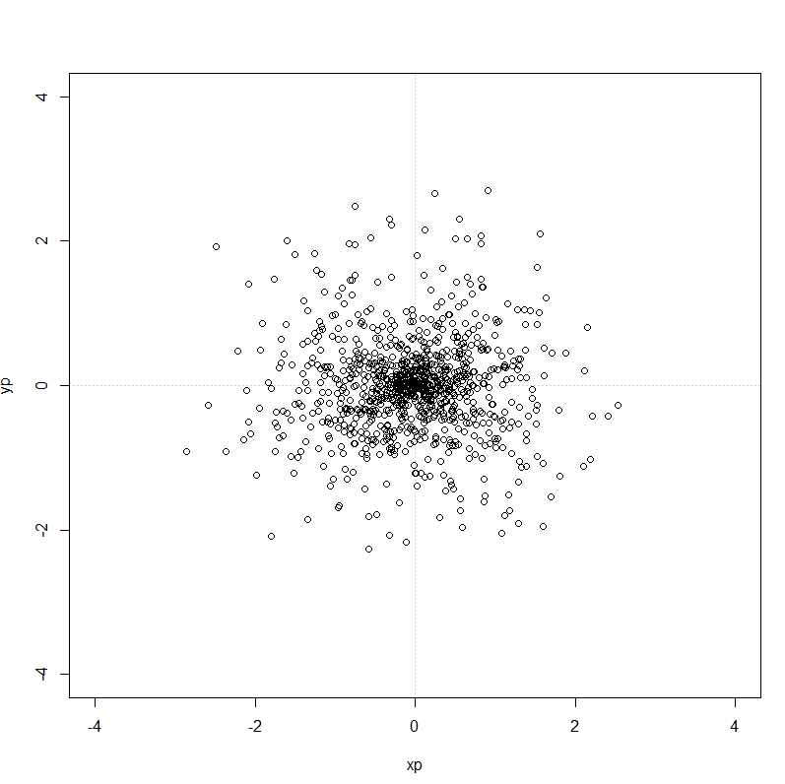

Kinematic motion model, initial pose (0,0), control (0,0), velocity and rotation noise sampled from N(0,1)

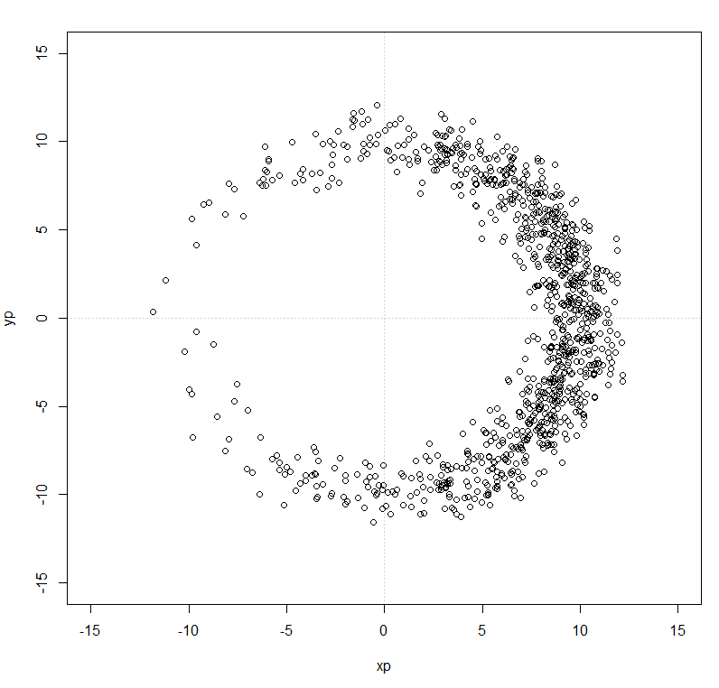

Kinematic motion model, initial pose (0,0), control (10,0), velocity and rotation sampled from N(0,1)

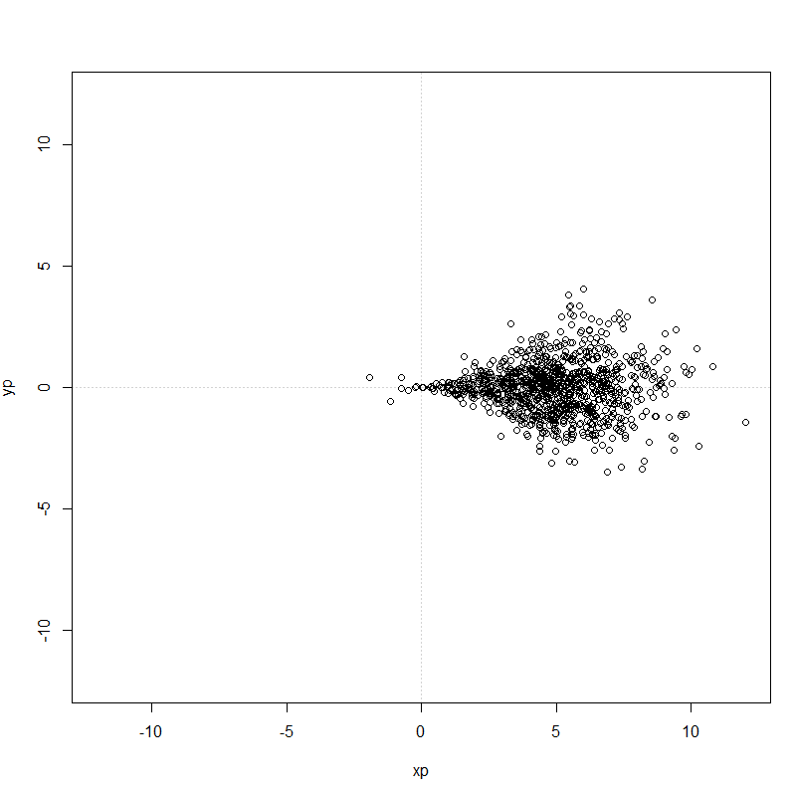

Kinematic motion model, initial pose (0,0), control (5,0), velocity noise sampled from N(0,2) and angle noise sampled from N(0,0.2)